ZC-OPSH510 OPS PC Supports 10th 11th Gen Intel Core i3/i5/i7 CPU,2*USB 3.0+4*USB2.0,1*Type C,1*RJ45,

1*OPS JAE Port,1*HDMI+1*DP,1*Power Button,2*Antennas,1*Power LED,1*HDD LED

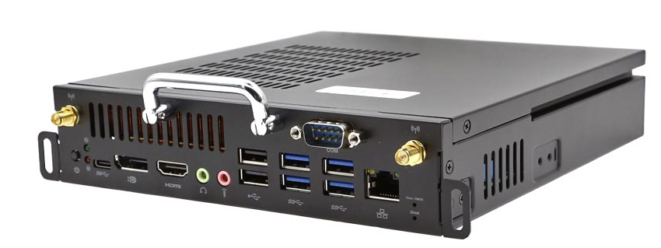

**Main Features:**

1.) Intel LGA 1200 Socket,Supports 10th 11th Gen Intel Celeron/Pentium/Core i3/i5/i7

2.) Standard OPS Frame,the Size is 180*195*42mm

3.) Rich Storage,1*M.2 NVME and 1*SATA 2.5’’

4.) M.2 Slot for WIFI Module

5.) OPS JAE Support 4096x2304@60Hz

6.) Good Quality:All Solid Cap,With Stable and Reliable Performance

**ZC-OPSH510 OPS PC Specification**

|  |  |
| --- | --- |
| CPU | Intel LGA 1200 Socket  Support 10th 11th Intel Celeron/Pentium/Core i3/i5/i7 |
| Chipset | H510 |
| RAM | 2*SO-DIMM DDR4,Max 64GB |
| Storage | 1*SATA 2.5’’  1*M.2 NVME/SATA |
| Graphics Card | CPU Integrated Intel UHD Graphics,Max Resolution 4096*2304@60Hz |
| Display | OPS JAE 80Pins: 4096*2304@60Hz HDMI 2.0 Signal  HDMI 1.4: 4096*2304@30Hz  DP1.2: 4096*2304@60Hz |
| Network Card | 1*RTL8111E,Gigabit |
| WIFI | Optional |
| I/O Ports | 1*DC Port  1*HDMI  1*DP  1*OPS JAE Port  2*USB 3.0  4*USB 2.0  1*USB Type C  1*RJ45  1*Power Button  1*Power LED  1*HDD LED  2*WIFI Antenna |
| Size | 180*195*42mm |